Affects of Urbanization on Stream Ecology:
Focusing on the Macroinvertebrate Community Affected by Suspended Sediment and Other Variables
Will Farrior, Beth Akers, Joel Bostic
Abstract
Macroinvertebrates are prevalent in WNC streams and can act as a proxy for chemical and physical changes in the stream (Smith, et al. 2005). Macroinvertebrates were collected from two morphologically similar sites on Long Branch creek in Cullowhee, NC. The two sites differed in the amount of development with in their reach. In addition to macroinvertebrates, pH, temperature, conductivity, dissolved oxygen, suspended sediment concentration, and various element and compound values were determined. No correlation was found between development and abundance or diversity of macroinvertebrates. A correlation did appear between Site 1 and Site 2 and suspended sediment concentration. Much more data needs to be collected to determine if this apparent correlation is significant.
Introduction
Macroinvertebrates represent a diverse ecosystem within mountain streams that can act as a proxy for various physical and chemical changes in the stream (Smith, et al., 2005). These changes can be influenced by varying levels of forest cover and increased building activity (Scott and Helfman, 2001). In this study, it will be determined if there is a correlation between the distribution of macroinvertebrates and suspended sediment, various element and compound concentrations, pH, conductivity, dissolved oxygen, or temperature between separate reaches of Long Branch Creek.
Suspended sediment is the measure of suspended particles in the water. These particles are typically smaller than 0.063 mm and primarily consist of silt and clay (U.S. E.P.A, 2010). Increased levels of suspended sediment can disrupt respiration of invertebrates in streams (Waters, 1995). Dissolved oxygen (DO) is the measurement of the amount of oxygen that has diffused into water. This naturally occurs through turbulence and decomposing organic material. Much of this organic matter comes from the riparian zone. Riparian zones are often altered in developed areas. Macroinvertebrates typically live in streams with DO levels of 4 mg/L or greater (Chessman and McElvoy, 2012). Macroinvertebrates, in particular the orders Ephemeroptera and Trichoptera, have been shown to decrease in abundance with more acidic water (Petrin et al., 2007). Land cover in the riparian zone has a crucial role in shading the stream and has a direct influence on water temperature. A decrease in land covers leads to a decrease in shade and an increase in temperature. Li et al. (2012) determined a correlation in rising temperatures and a decrease in both abundance and richness of macroinvertebrates. Weathering of primary minerals through hydrolysis in soils, e.g. feldspar, use $H^{+}$ ions, in effect neutralizing acids (Brady and Weil, 2002). Driscoll, et al. (2001), note that the acid buffering capabilities of soils and streams can decrease for short periods when stream discharge is highest. This is related to the water table being raised, during high precipitation events, closer to the surface and away from areas of weathering of minerals. Increase in urbanization can greatly reduce infiltration of water into soil (Pitt, et al., 2002) negating the acid neutralizing properties of soils. Bell (1970) showed that certain species of mayflies and stoneflies are susceptible to acidic conditions, with less than 50% survival rates at pH less than 5. (consider adding graphs to a table at back of paper) Several studies have analyzed anthropogenic sources of various nutrients and the effect on macroinvertebrates. Yaun (2010) analyzed total Nitrogen, total Phosphorus, in addition to chloride, sulfate, ammonium, and bicarbonate ions. In certain types of streams, these nutrient values negatively correlated with richness in benthic macroinvertebrates. Conductivity is yet another variable that can affect macroinvertebrates, it measures the ability of water to conduct electrical current, largely determined by dissolved cations and anions in the solution (Monitoring Water Quality, EPA, 2007). Echols, et al., (2007) used Ephemoptera-Plecoptera-Trichoptera abundance tests to show drastically reduced counts in areas of high conductivity as a result of brine ponds. Conductivity measurements peaked at 10,000 µS/cm and greatly decreased immediately downstream of the brine ponds. Combined, the cited literature provides a compelling case for the use of macroinvertebrates as a proxy for overall stream health. The increase in development is apparent upon initial inspection of the length of Long Branch Creek. Figure 1 is an aerial photo of the watershed from 2005 with the creek highlighted. Figure 2 is an aerial photo of the watershed from 2009, again with the creek highlighted and also new development circled. Figure 3 shows a map from the US Geological Survey’s National Land Cover Database (2006). The legend is included with this map. It is apparent that as one follows Long Branch creek to Cullowhee Creek that land cover changes from primarily forested to grassland and urban.
We hypothesize that development and urbanization along Long Branch creek will have no effect on the distribution of macroinvertebrates.
Methods
Data collection took place from Long Branch Creek in Cullowhee, NC. Data was taken from two sites in the creek with similar flow characteristics to one another. Data was taken from an upper, less developed portion of the stream located at approximately 35°18'28.03"N, 83°11'18.39"W. Data was collected from a lower portion of the stream, in a more developed area directly before the stream enters a culvert under Highway 107 and empties into Cullowhee Creek. This site is located at approximately 35°17'50.56"N, 83°12'41.55"W.
Macroinvertebrates collection protocols:
Starting at one side of the stream, the kick net will be placed in the water for a thirty second collection period. Researchers will gently kick up the creek substrate so that the loosened material will move into the kick-net. After each collection, the contents of the kick net will be deposited into a bucket. After each collection period, the kick net will be moved horizontally from the bank at an interval of one kick net width per testing period. Samples will be taken until the entire width of the stream has been crossed with the kick net. The macroinvertebrate contents of the bucket will be separated using a sieve. The organisms will placed in an 80% ethanol solution for later identification. Materials needed for this collection include: waders, kick net (or d-frame dip net), gloves, buckets, sieve, ethanol solution, and storage containers.
Macroinvertebrates will be collected from the bed substrate, specifically rocks and large cobbles. During a period of ten minutes per site, researchers will sample by rubbing the surfaces of collected substrates into the temporary containers. Researchers will move around the designated section of stream in to sample as many different substrates as is possible. Materials needed for this collection include: waders, gloves, ethanol solution, and storage containers.
During a pilot collection period of macroinvertebrates and consequent keying it was determined that the orders Ephemoptera, Plecoptera, Trichoptera, and Coleoptera are present in Long Branch Creek. During data collection periods macroinvertebrates will be keyed out to genus and numbers of organisms recorded.
Measurement of suspended sediment will follow these procedures:
During each collection, at least 200 mL at three sites in separate bottles by holding the container underwater with the nozzle in the same direction of stream flow and at approximately the same velocity. Samples will be brought to the lab for analysis. Paper filters will be weighed and placed on top of funnel in filter flask. Using a vacuum filtration system, sample will be poured through filters into filter flasks. The vacuum will run for 4 hours. Weigh filters again and subtract original weight. Multiply sediment weight by 10^6 and divide by remaining water volume to determine parts per million (ppm). Materials needed for this include: 250 ml bottles, filter papers, filter flasks, digital scale, and vacuum hoses.
Calculation of various elements, ions, and compound concentrations will be determined using a Hach DR/890 Portable Colorimeter. 250 mL samples will be collected from the stream using bottles rinsed with deionized water and analyzed in the lab. Dissolved oxygen and temperature measurements will be recorded using a YSI Model 55 dissolved oxygen meter following Sinclair’s (2012) procedure. Stream discharge will be recorded by determining the cross-sectional area of stream using a tape measure and then using a flow meter to record velocity. Velocity multiplied by cross-sectional area equals stream discharge. pH values will be recorded using a Scientific Instruments IQ150.
Abundance and distribution of macroinvertebrates will be quantified using a modified version of Simpon’s Diversity Index: D = (∑n(n-1))/(N(N-1), with n=total number of taxa and N=total number of organisms. T-tests will be used to determine if there are significant differences between variables in separate sites in the stream.
Results
Temperature, pH, conductivity, dissolved oxygen, copper, iron, phosphate, and nitrate values are presented in Table 1.
Table 1
 |  | Site 1 (School bus turn around) | Site 2 (Campus apartments)
pH | 4/9/13 | 6.75 | 7.11
 | 4/19/13 | 6.32 | 6.79
Dissolved Oxygen (mg/L) | 4/9/13 | 9.9 | 9.97
 | 4/19/13 | 9.95 | 9.23
Temperature ($℃)$ | 4/9/13 | 11.6 | 13.1
 | 4/19/13 | 13.6 | 15.3
Conductivity (mV) | 4/9/13 | 5.1 | 11.4
 | 4/19/13 | 37.4 | 26.6
Suspended Sediment Concentration (ppm) | 4/9/13 | 14.78 | 54.72
 | 4/19/13 | 45.42 | 292
Copper (mg/L) | 4/9/13 | 0.16 | 0.06
 | 4/19/13 | 0.02 | 0.21
Iron (mg/L) | 4/9/13 | 0.09 | 0.28
 | 4/19/13 | 0.23 | 0.26
Nitrate (mg/L) | 4/9/13 | 1.1 | 4
 | 4/19/13 | 1.1 | 1.9
Phosphate (mg/L) | 4/9/13 | 0.31 | 0.13
 | 4/19/13 | 0.21 | 0.28

Macroinvertebrate data are presented in Table 2.
Table 2
Site 1
Taxa | Number
Plecoptera: Peltoperlidae | 1
Ephemerellidae: Danella | 4
Ephemeroptera Heptageriidae epeorus | 5
Ephemeroptera Potamanthidae anthopotamus | 4
Decapoda Cambaridae Orconectes virilis | 1
Megaloptera Corydalidae nigronia | 1
Tricoptera Rhyacophilidae rhyacophila | 1
Tricoptera Hydropsychidae Arctopsychinae parapsyche | 1
Ephemeroptera Ameletidae ameletus | 8
Tricoptera (unknown small larvae,similar) | 2
Diptera Cyclorrhaphous Brachycera | 1
Ephemeroptera Tricorythidae tricorythodes | 4
Plecoptera Pelodidae isoperla | 3
Odonata Anisoptera Cordulegastridae cordulegaster | 1
Tipulidae Limoniinae antocha | 1

Site 2
Taxa | Number
Molusca Lymnaeidae fossaria f. parva | 2
Oligochaeta (Unknown) | 5
UNKOWN | 1
Plecoptera Pteronarcyidae pteronarcella | 1
Coleoptera Psephenidae dicranopselaphus | 8
Tricoptera Glossosomatidae Glossosomatinae anagapetus | 1
Ephemeroptera Tricorythidae tricorythodes | 2
Ephemeroptera Neoephemeridae neoephemera | 4
Plecoptera Leuctridae despaxia | 2
Ephemeroptera Ephemerellidae ephemerella | 1
Ephemeroptera Ephemerellidae attenella | 8
Coleoptera Psephenidae psephenus | 1
Tricoptera Glossosomatidae culoptila | 4
Tricoptera Hydropsychidae Macronematinae leptonema | 2
Megaloptera Corydalidae nigronia | 3
Ephemeroptera Baetidae fallceon | 5
Ephemeroptera Baetidea barbaetis | 1
Ephemeroptera Ameletidae ameletus | 1
Plecoptera Taeniopterygidae stophopteryx | 1

Analysis of collected data will be completed plotting variables measured (pH, Eh, element and compound concentrations, temperature etc.) against macroinvertebrate diversity. Calculation of p-values will determine the probability that the relationship between the variables is significantly significant or due to chance. Lower p-values will indicate that the significance is not likely due to chance with values lower than .01 typically indicating a strongly significant relationship. A correlation coefficient will be calculated to determine how linearly related the variables are. A high p-value and a correlation coefficient near zero would support the null hypothesis that urbanization, development, and the possible physical and chemical effects of these have no effect on the distribution of macroinvertebrates. Lower p-values of the regression lines of the independent and dependent variable would not support the null hypothesis. Analysis of each variable’s plot with macroinvertebrate distribution will allow the possibility to isolate variables and determine if one, or more, has any or more impact than the others.
Discussion
The urbanization of any environment is part of an unending race to become a more “civilized” and modern world. To those who are unaware of the negative effects that urbanization may have, all may seem well. However, it is imperative that as citizens of this planet we are conscious of the impact that we are having on our environment as we move forward. In order to keep an eye on our actions there must be an effort to conserve, to the best of our ability, the natural niches. It is for this reason that research has been done on the impact of urbanization on macroinvertebrates. Quantifying the impact of urbanization on macroinvertebrates is a step in developing models that may be used to fight for the ecology of streams as this race continues.
Results that do not support our hypothesis will show that the urbanization of land near streams has a negative impact on macroinvertebrate diversity. Macroinvertebrates are an crucial factor of many streams, and serve to break down much of the organic matter that makes its way into the stream. With a lower population (or diversity?) of macroinvertebrates there may be an increase in organic materials, and as a result the stream may suffer. Results that do support our hypothesis would provide evidence that the particlular urbanization along Long Branch Creek ( which you still have to describe in the intro) is having little affect on the macroinvertebrate diversity. Supporting results would lead to the questioning of our research. Proposed questions would be: If the data shows that the population of macroinvertebrates is being affected, but not by urbanization, what other factors may be causing the changes seen in the population? Though urbanization has not affected the population of macroinvertebrates in this stream, could it have an affect on other streams?
Further research may be done on the topic of macroinvertebrate population and diversity in areas of increasing urbanization. The model that has been used to do research at Long Branch Creek may be implemented at other sites in order to obtain comparative data. If the impact of urbanization is significant, studies as to the prevention of this impact could follow suit.

References
Bell, H.L. (1970). Effect of low pH on the survival and emergence of aquatic insects. Water Research, 5313-319.
Brady, N.C., Weil, R.R. (2002). Elements of the Nature and Properties of Soils (2nd ed.). Upper Saddle River, NJ: Pearson Education Inc.
Chessman, B., & McEvoy, P. (2012). Insights into Human Impacts on Streams from Tolerance Profiles of Macroinvertebrate Assemblages. Water, Air & Soil Pollution, 223(3), 1343-1352.
Driscoll, C., Lawrence, G., Bulger, A., Butler, T., Cronan, C., Eagar, C., & ... Weathers, K. (2001). Acidic deposition in the northeastern United States: Sources and inputs, ecosystem effects, and management strategies. Bioscience, 51(3), 180-198.
Echols, B., Currie, R., & Cherry, D. (2009). Influence of Conductivity Dissipation on Benthic Macroinvertebrates in the North Fork Holston River, Virginia Downstream of a Point Source Brine Discharge during Severe Low-Flow Conditions. Human And Ecological Risk Assessment, 15(1), 170-184.
Helfman, G.S., Scott, M.C.(2001): Native Invasions, Homogenization, and the Mismeasure of Integrity of Fish Assemblages, Fisheries, 26:11, 6-15
Li, F., Cai, Q., Jiang, W., & Qu, X. (2012). The response of benthic macroinvertebrate communities to climate change: evidence from subtropical mountain streams in Central China. International Review Of Hydrobiology, 97(3), 200-214.
National Land Cover Database, U.S. Geological Survey, 2006 (Map). Retrieved 15 April 2012 from http://www.mrlc.gov/nlcd2006.php.
Petrin, Z., Laudon, H., & Malmqvist, B. (2007). Does freshwater macroinvertebrate diversity along a pH-gradient reflect adaptation to low pH?. Freshwater Biology, 52(11), 2172-2183
Pitt, R., Chen, S., Clark, S., & Ong, C. (2002). Urbanization factors affecting infiltration. American Water Resources Association Technical Publication Series, 02-2181-186.
Sinclar, J. (2012). YSI Model 55: Dissolved Oxygen System. Western Carolina University, NC. 2p.
Smith, J.G., J.J. Beauchamp, and A.J. Stewart, "Alternative approach for establishing acceptable thresholds on macroinvertebrate community metrics," Journal of The North American Benthological Society, 24(2)(2005), 428-440.
U.S. EPA (Environmental Protection Agency). 2010. Causal Analysis/Diagnosis Decision Information System (CADDIS). Office of Research and Development, Washington, DC. Available online at http://www.epa.gov/caddis. Last updated September 23, 2010.
U.S. EPA (Environmental Protection Agency). 1997. Volunteer Stream Monitoring: A Methods Manual. Office of Water, Washington, DC. Available online at http://water.epa.gov/type/rsl/monitoring/stream_index.cfm.
Waters, T. F. (1995). Sediment in streams: Sources, biological effects, and control. American Fisheries Society Monograph 7.
Yaun, Lester, L. (2010). Estimating the effects of excess nutrients on stream macroinvertebrates from observational data. Ecological Applications, 20(1), 110-125.

Figure 1
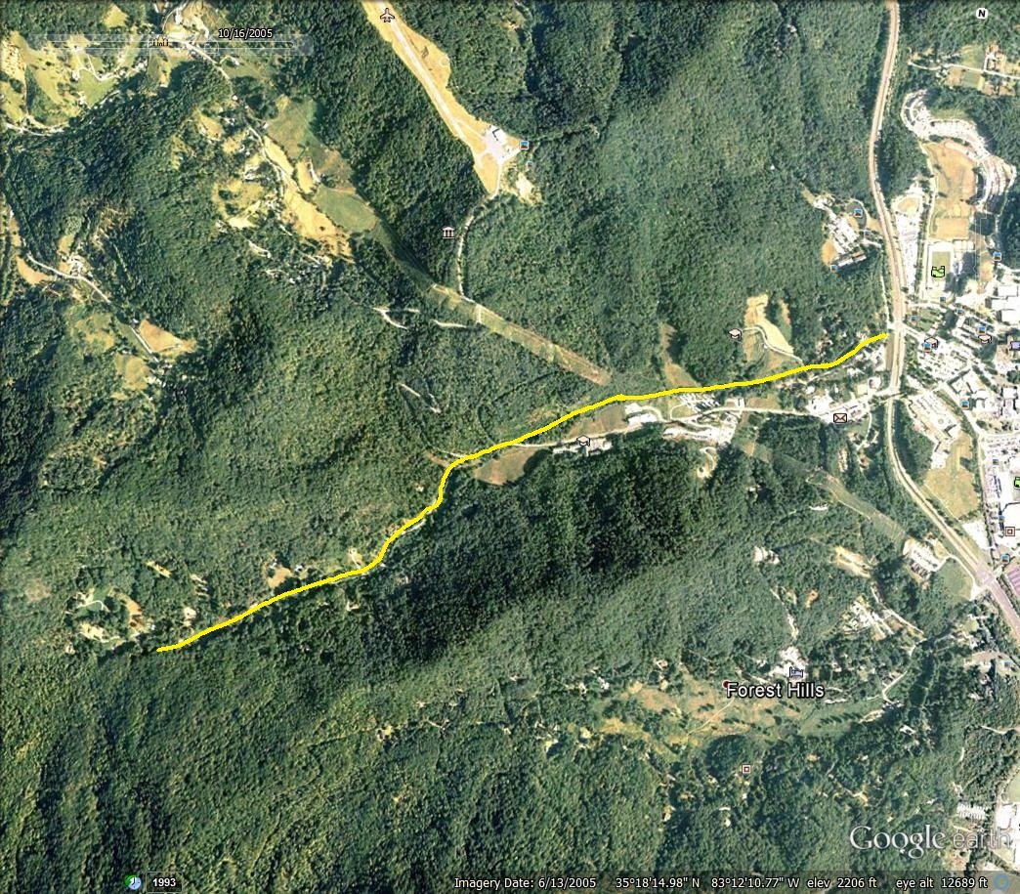
Figure 2
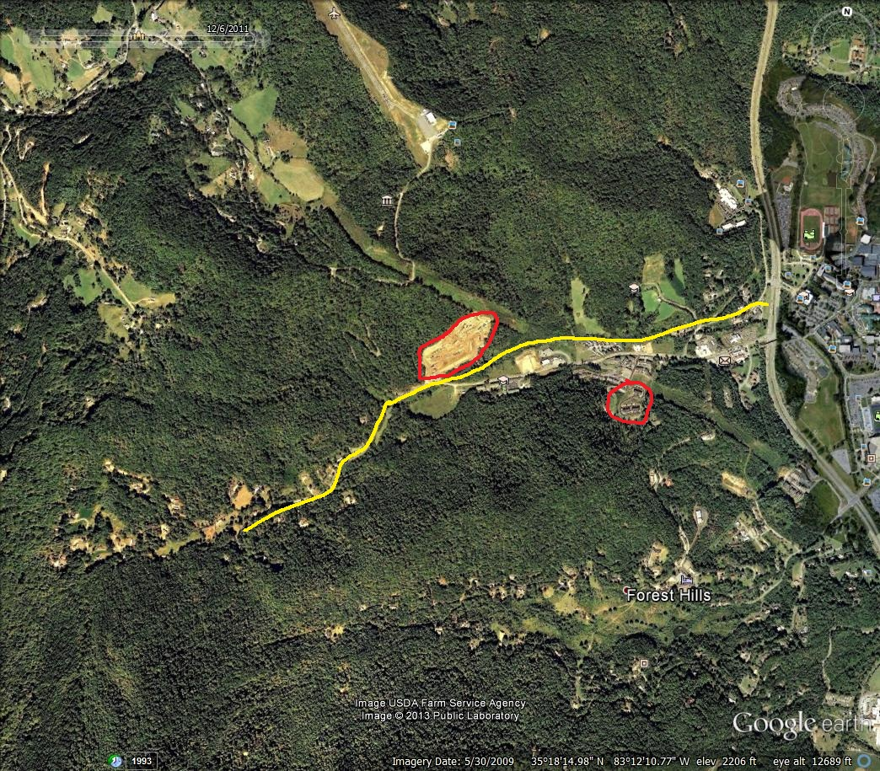
Figure 3
